1 Cycle_Trace/TouTiao_Trace_NO_EVENTS_CYCLE/TouTiao_VIDEO_FRAME_TRACE_cpu7_NO_TimeStamp"

|  |  |  |  |  |  |  |  |  |  |
| --- | --- | --- | --- | --- | --- | --- | --- | --- | --- |
| 绝对误差值平均x = ∑abs(real[i] – predict[i]) / (real数组的长度) | N =1 | N = 2 | N =3 | N =4 | N =5 | N =6 | N = 7 | N = 8 | N = 9 |
| WMA | 8229123 | 8004980 | 8042616 | 8014063 | 7880807 | 7855192 | 7806376 | 7759098 | 7770093 |
| AVERAGE | 8229123 | 8072597 | 8132477 | 8106915 | 7674614 | 7837001 | 7750373 | 7708852 | 7950871 |
| WALT | 8229123 | 9686208 | 10121125 | 10233738 | 9899978 | 9975731 | 9943135 | 10017982 | 10198712 |
| MAX | 8229123 | 11538407 | 1447007 | 167822095 | 19257898 | 21822218 | 24017608 | 26117570 | 28428956 |

|  |  |  |  |  |  |  |  |  |  |
| --- | --- | --- | --- | --- | --- | --- | --- | --- | --- |
| 相对误差率平均x =(∑（predict[i] – real[i]）/ real[i])/ (real数组长度) | N = 1 | N = 2 | N =3 | N =4 | N =5 | N =6 | N = 7 | N = 8 | N = 9 |
| WMA | 0.5 | 0.6 | 0.76 | 0.8 | 0．8 | 0.8 | 0.8 | 0.8 | 0.8 |
| AVERAGE | 0.5 | 0.6 | 0.89 | 0.87 | 0.84 | 0.84 | 0.83 | 0.86 | 0.89 |
| WALT | 0.5 | 0.88 | 1.15 | 1.17 | 1.17 | 1.17 | 1.17 | 1.20 | 1.23 |
| MAX | 0.5 | 1.25 | 2.23 | 2.61 | 2.96 | 3.37 | 3.62 | 3.87 | 4.20 |

|  |  |  |  |  |  |  |  |  |  |
| --- | --- | --- | --- | --- | --- | --- | --- | --- | --- |
| 相对误差率绝对平均x =(∑（（abs(predict[i] – real[i])）/ real[i])/ (real数组长度) | N =1 | N = 2 | N =3 | N =4 | N =5 | N =6 | N = 7 | N = 8 | N = 9 |
| WMA | 0.6 | 0.74 | 0.87 | 0.91 | 0.92 | 0.93 | 0.93 | 0.94 | 0.95 |
| AVERAGE | 0.6 | 0.8 | 1.00 | 0.98 | 0.95 | 0.95 | 0.95 | 0.98 | 1.00 |
| WALT | 0.6 | 0.98 | 1.23 | 1.25 | 1.24 | 1.24 | 1.24 | 1.27 | 1.29 |
| MAX | 0.6 | 1.33 | 2.30 | 2.66 | 3.00 | 3.41 | 3.65 | 3.91 | 4.23 |

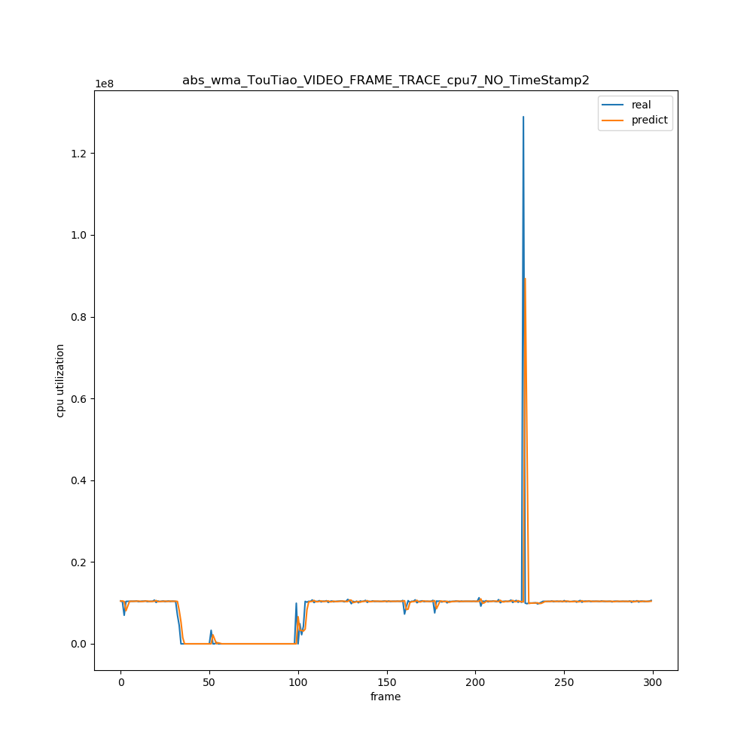

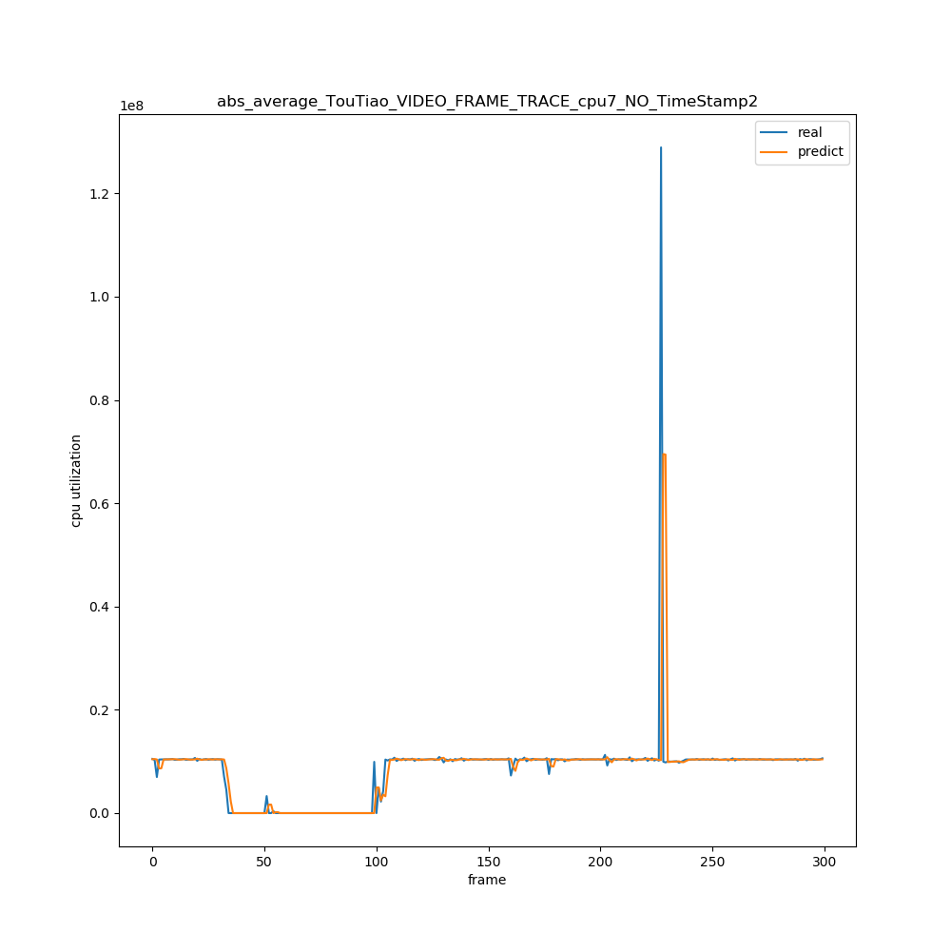

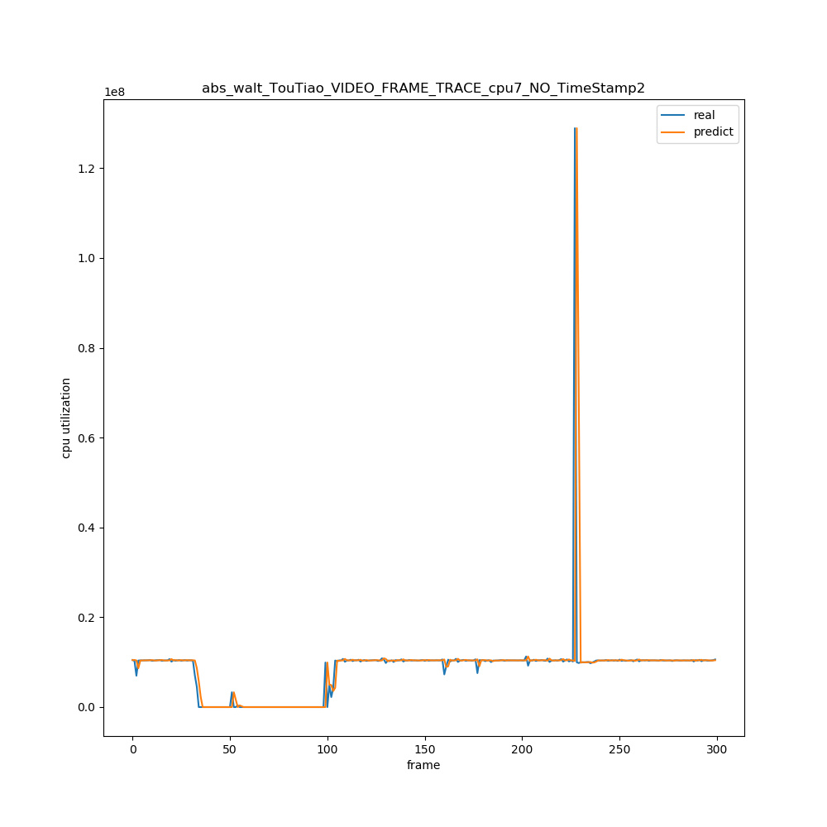

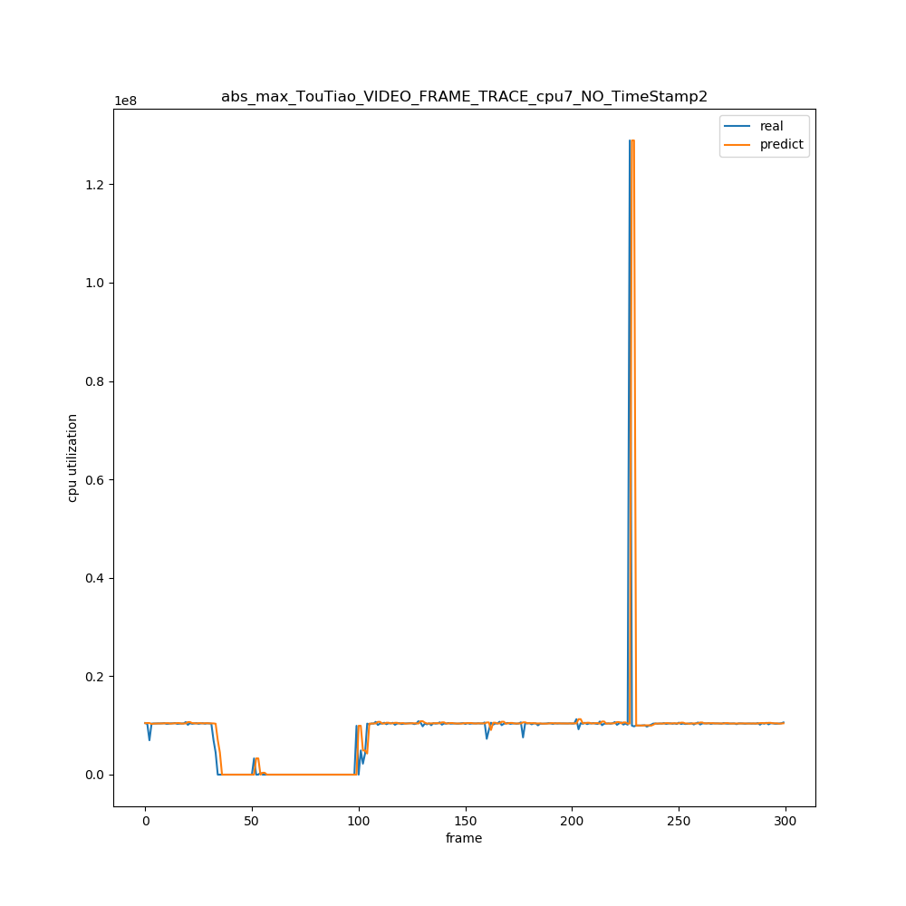

预测与实际值图

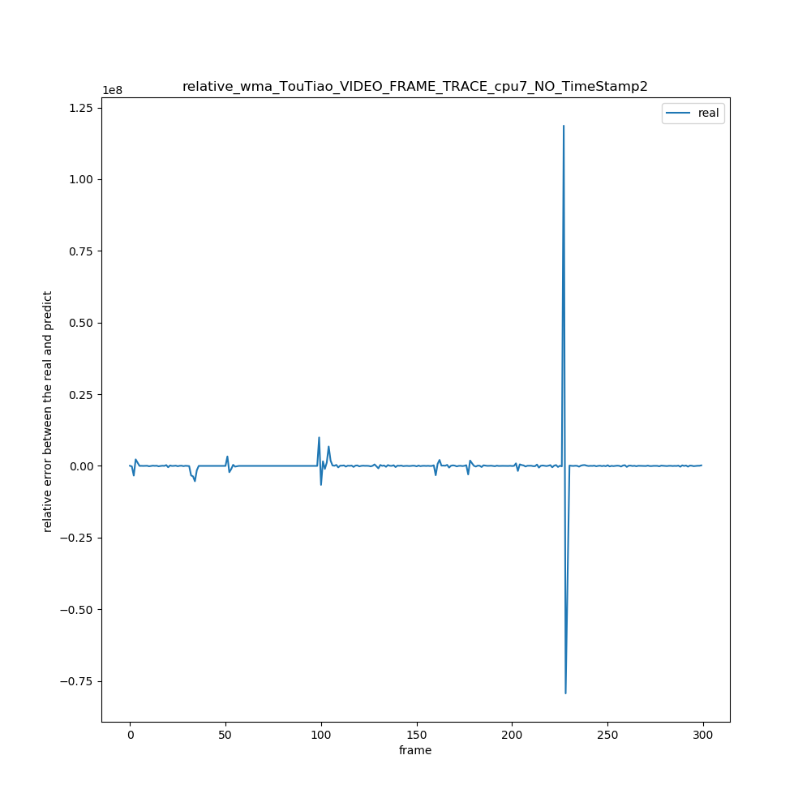

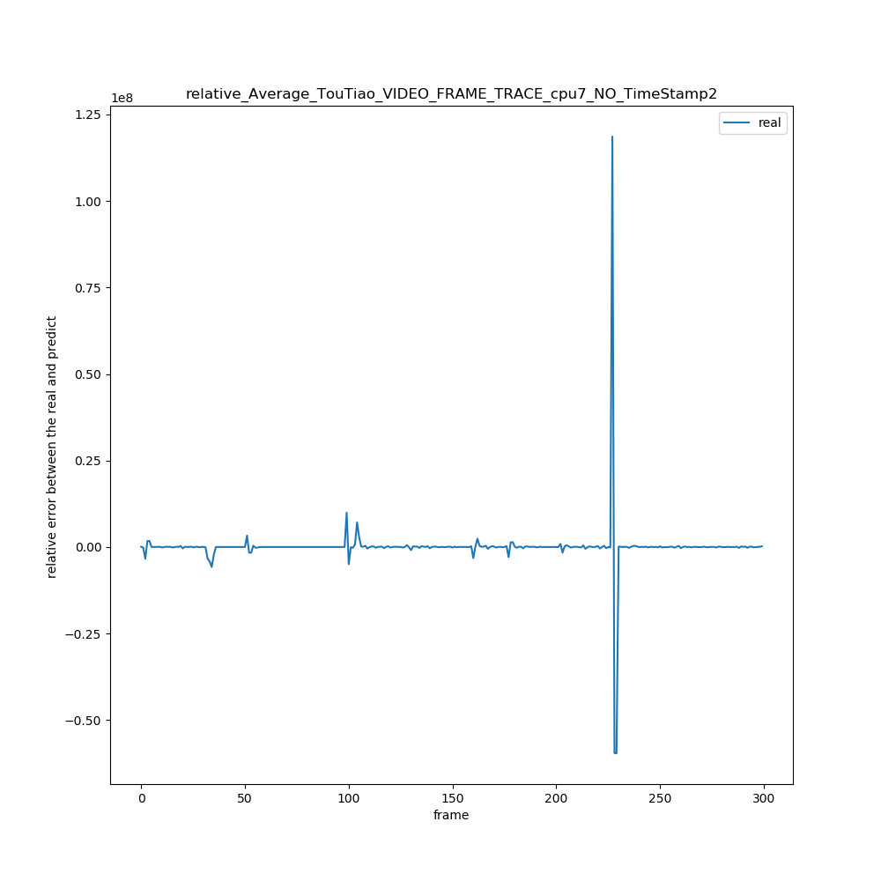

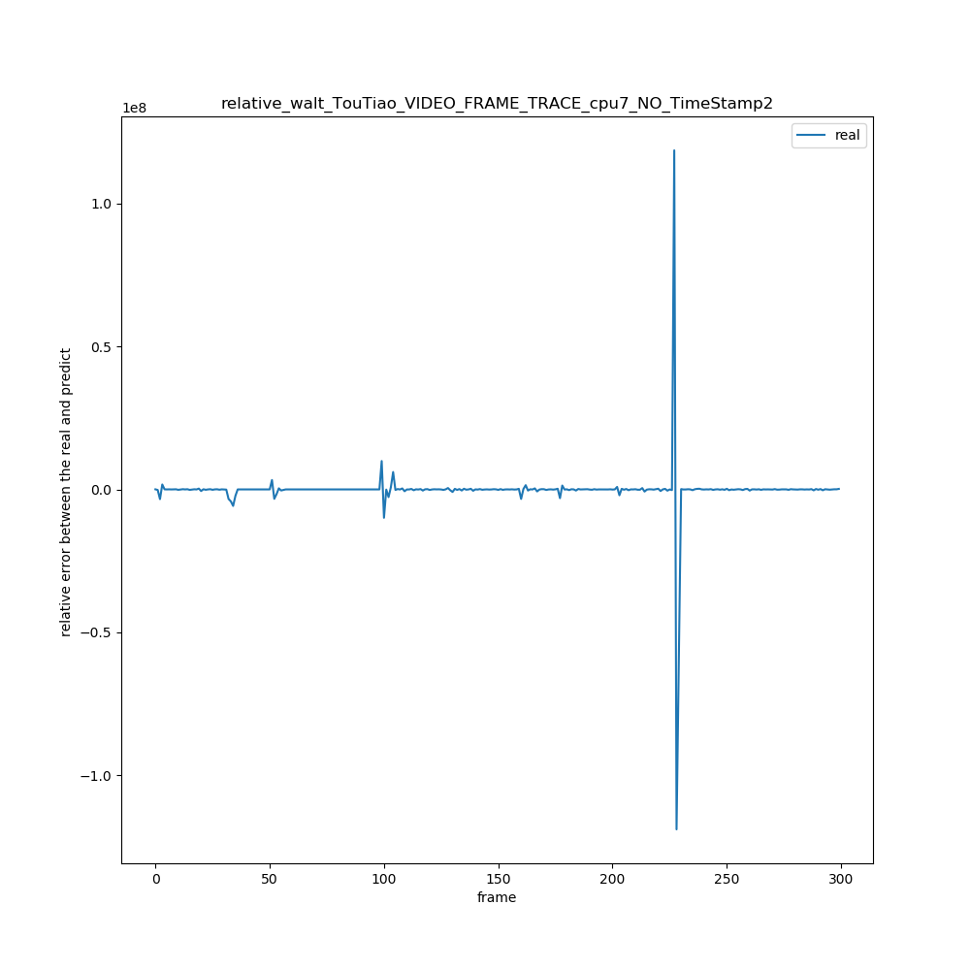

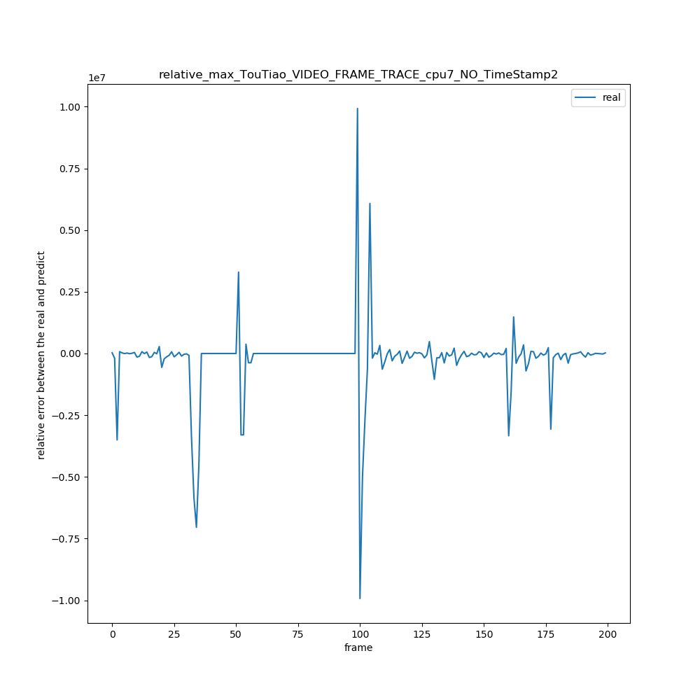

预测与实际之差

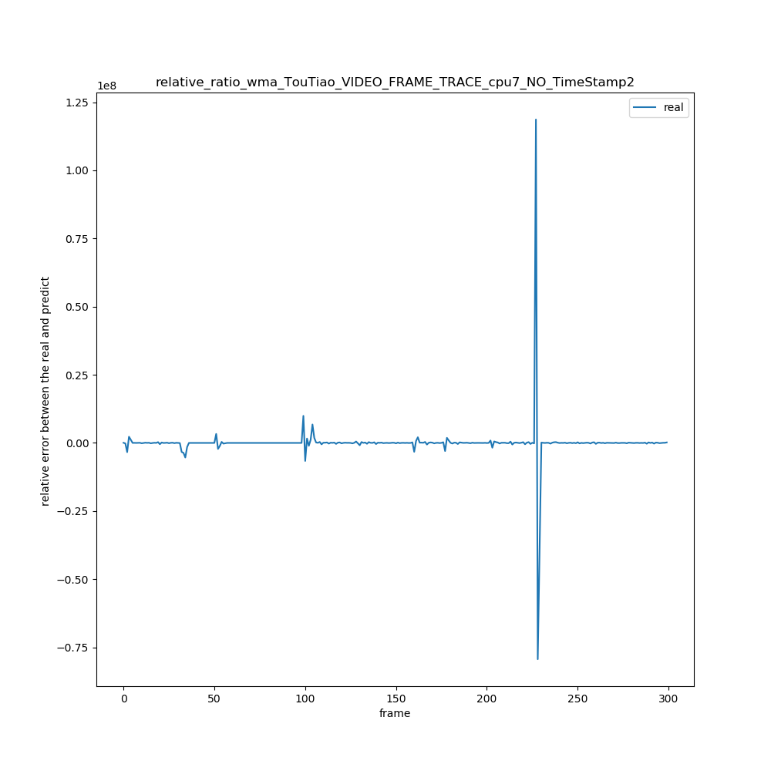

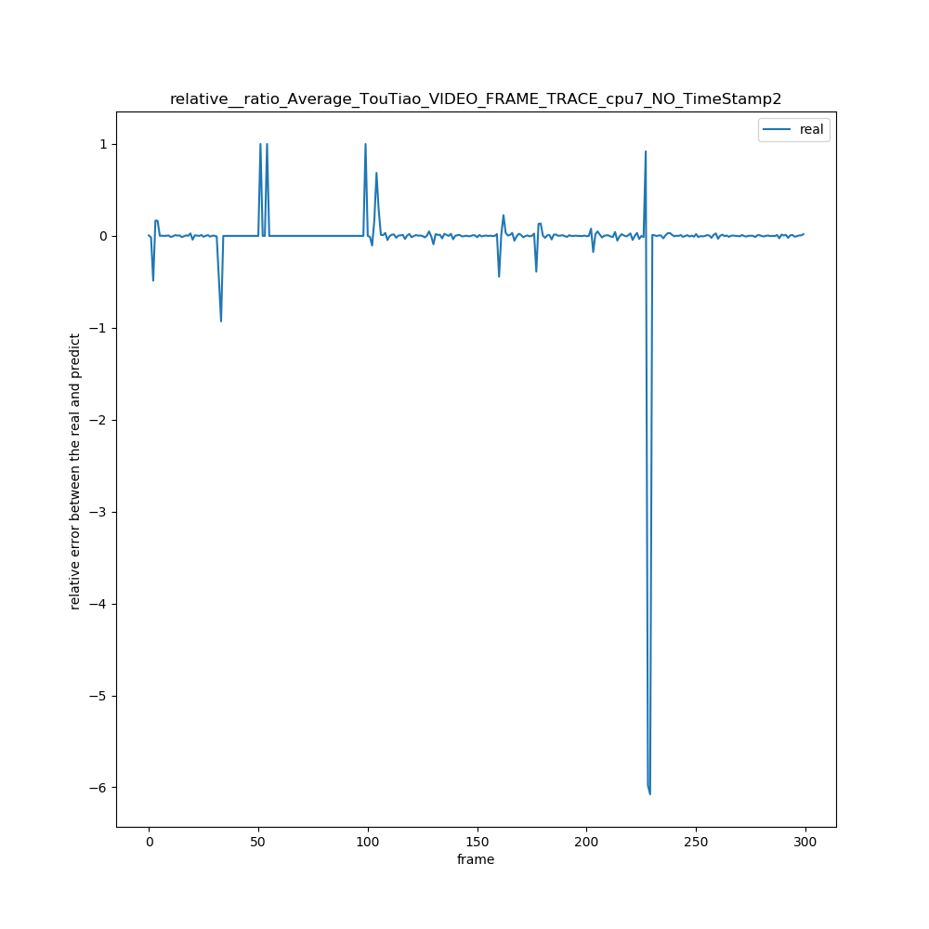

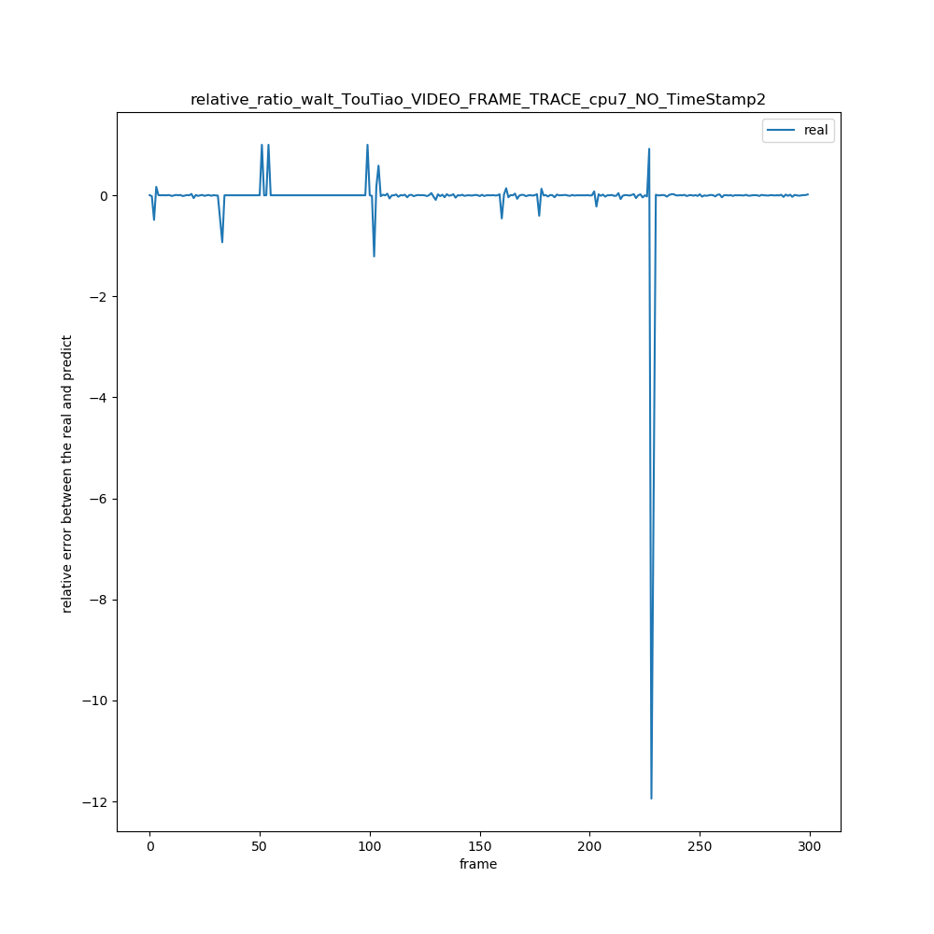

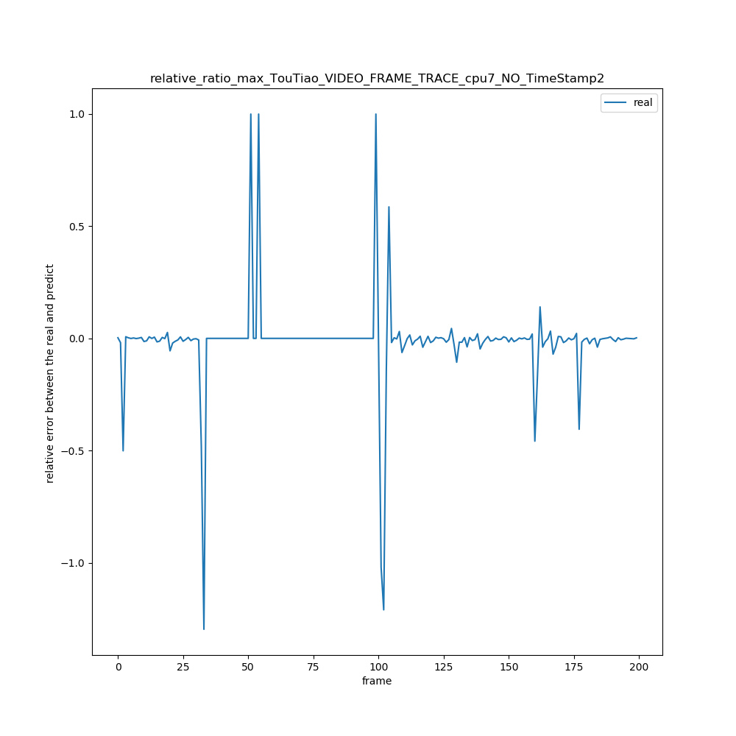

2 TouTiao_VIDEO_FRAME_TRACE_cpu5_NO_TimeStamp

|  |  |  |  |  |  |  |  |  |  |
| --- | --- | --- | --- | --- | --- | --- | --- | --- | --- |
| 绝对误差值平均x = ∑abs(real[i] – predict[i]) / (real数组的长度) | N = 1 | N =2 | N =3 | N = 4 | N = 5 | N = 6 | N = 7 | N =8 | N =9 |
| WMA | 1515430 | 1470143 | 1455328 | 1452659 | 1455132 | 1463110 | 1474489 | 1484326 | 1492393 |
| AVERAGE | 1515430 | 1508324 | 1492546 | 1495085 | 1500207 | 1517535 | 1539832 | 1543948 | 1550391 |
| WALT | 1515430 | 1488349 | 1485422 | 1472107 | 1472948 | 1482581 | 1492959 | 1498110 | 1497853 |
| MAX | 1515430 | 1628947 | 1762265 | 1881799 | 1983383 | 2068568 | 2150612 | 2226322 | 2292656 |

|  |  |  |  |  |  |  |  |  |  |
| --- | --- | --- | --- | --- | --- | --- | --- | --- | --- |
| 相对误差率平均x =(∑（predict[i] – real[i]）/ real[i])/ (real数组长度) | N =1 | N = 2 | N =3 | N =4 | N =5 | N =6 | N = 7 | N = 8 | N = 9 |
| WMA | 0.6 | 0.76 | 0;83 | 0.89 | 0.95 | 1.01 | 1.06 | 1.11 | 1.16 |
| AVERAGE | 0.6 | 0.83 | 0.91 | 0.98 | 1.07 | 1.15 | 1.22 | 1.29 | 1.36 |
| WALT | 0.6 | 1.02 | 1.19 | 1.27 | 1.37 | 1.46 | 1.53 | 1.62 | 1.69 |
| MAX | 0.6 | 1.43 | 1.98 | 2.38 | 2.75 | 2.96 | 3.27 | 3.60 | 3.82 |

|  |  |  |  |  |  |  |  |  |  |
| --- | --- | --- | --- | --- | --- | --- | --- | --- | --- |
| 相对误差率绝对平均x =(∑（（abs(predict[i] – real[i])）/ real[i])/ (real数组长度) | N =1 | N = 2 | N =3 | N =4 | N =5 | N =6 | N = 7 | N = 8 | N = 9 |
| WMA | 1 | 1.10 | 1.16 | 1.20 | 1.25 | 1.31 | 1.36 | 1.41 | 1.45 |
| AVERAGE | 1 | 1.17 | 1.23 | 1.29 | 1.37 | 1.45 | 1.52 | 1.59 | 1.66 |
| WALT | 1 | 1.29 | 1.41 | 1.47 | 1.56 | 1.64 | 1.72 | 1.79 | 1.86 |
| MAX | 1 | 1.64 | 2.12 | 2.47 | 2.82 | 3.02 | 3.32 | 3.64 | 3.86 |

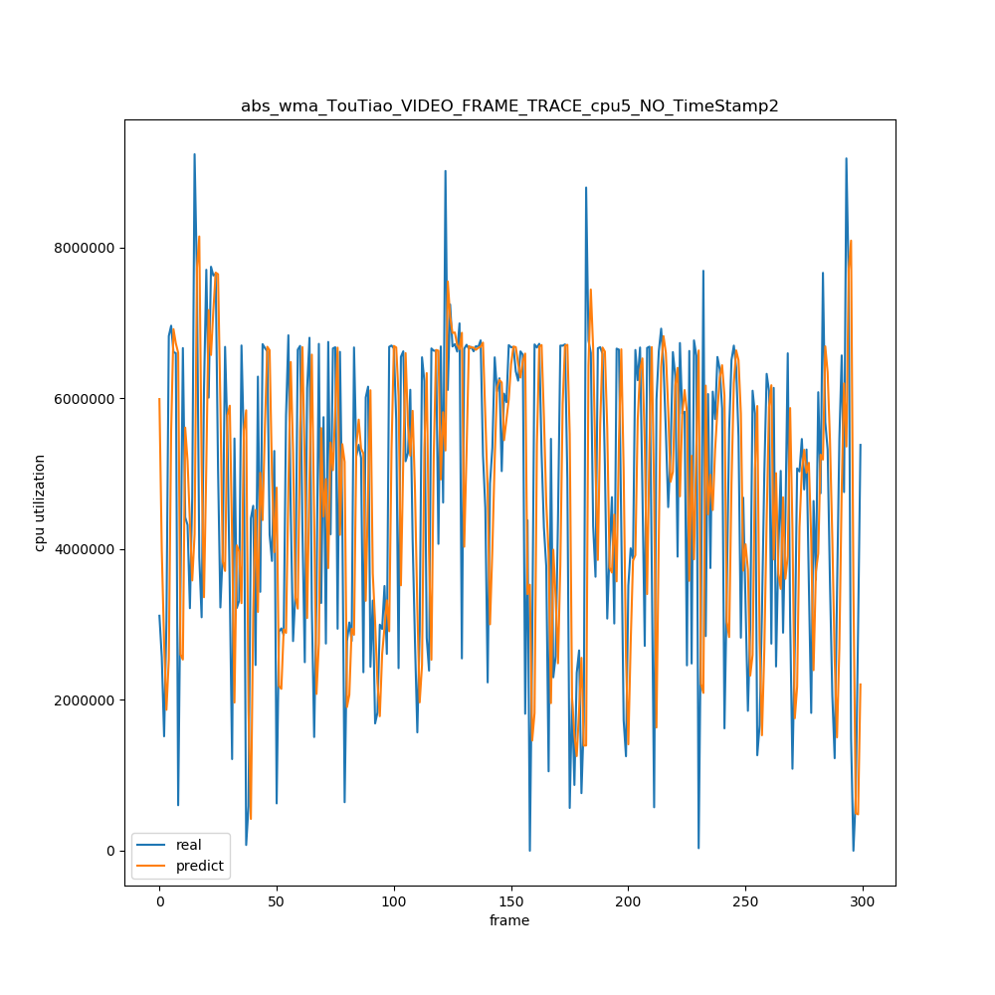

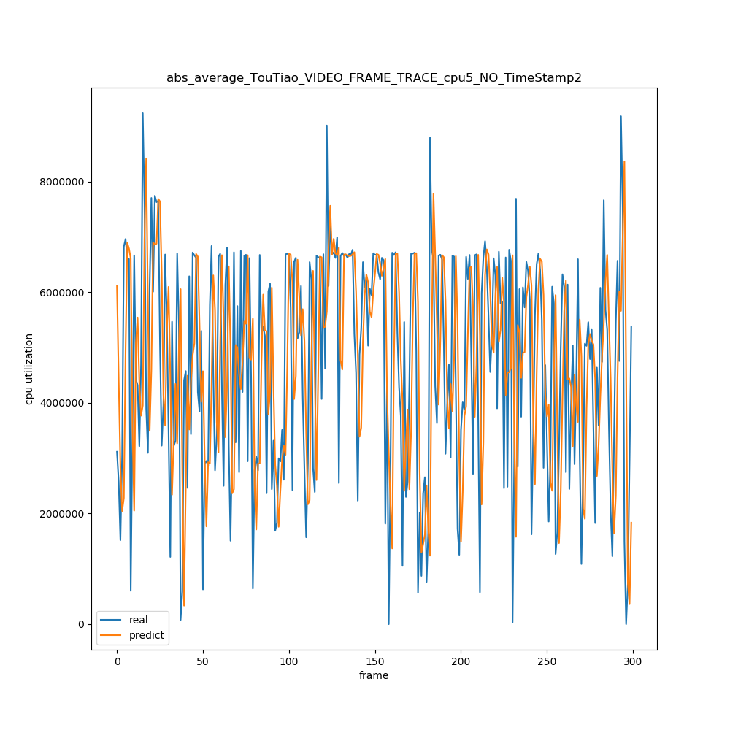

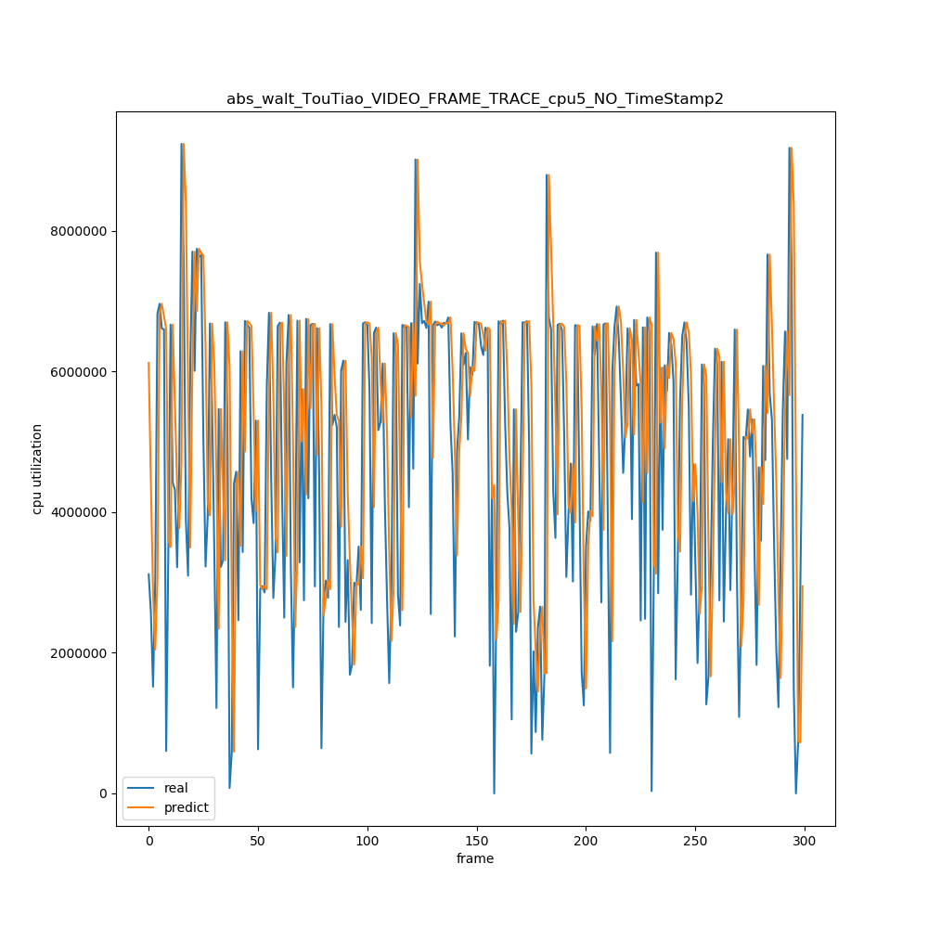

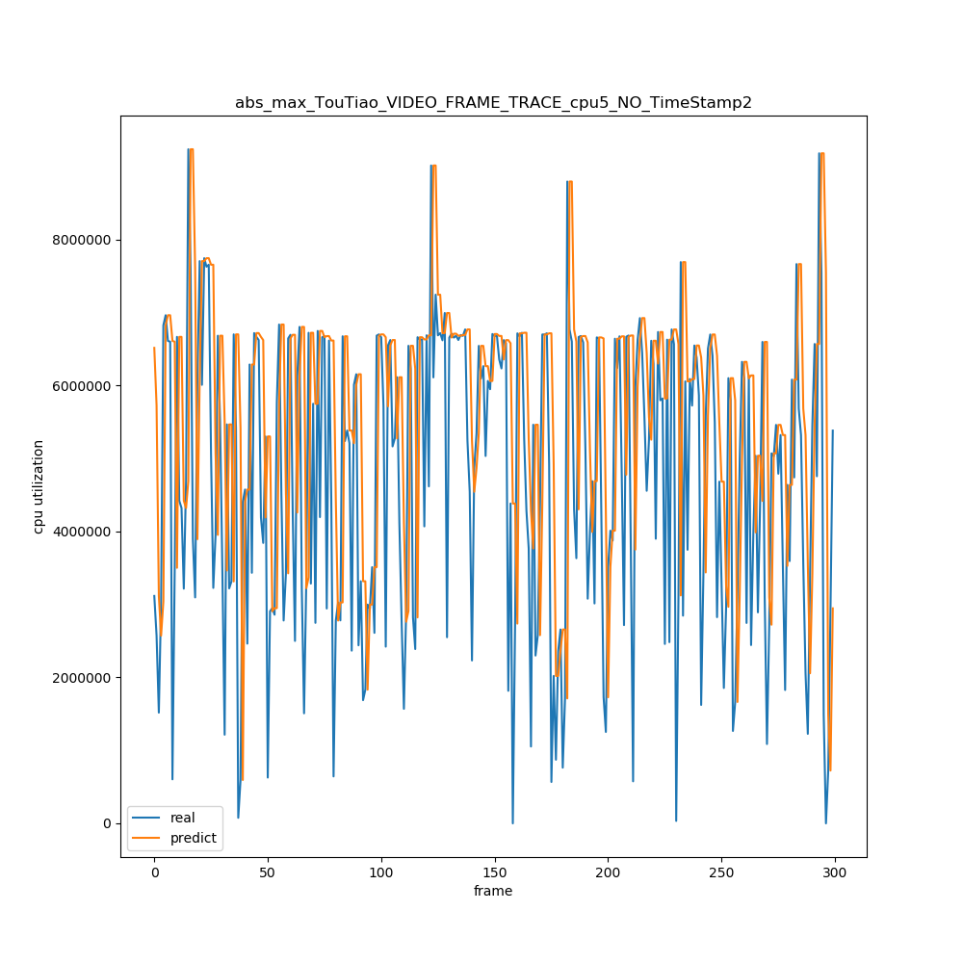

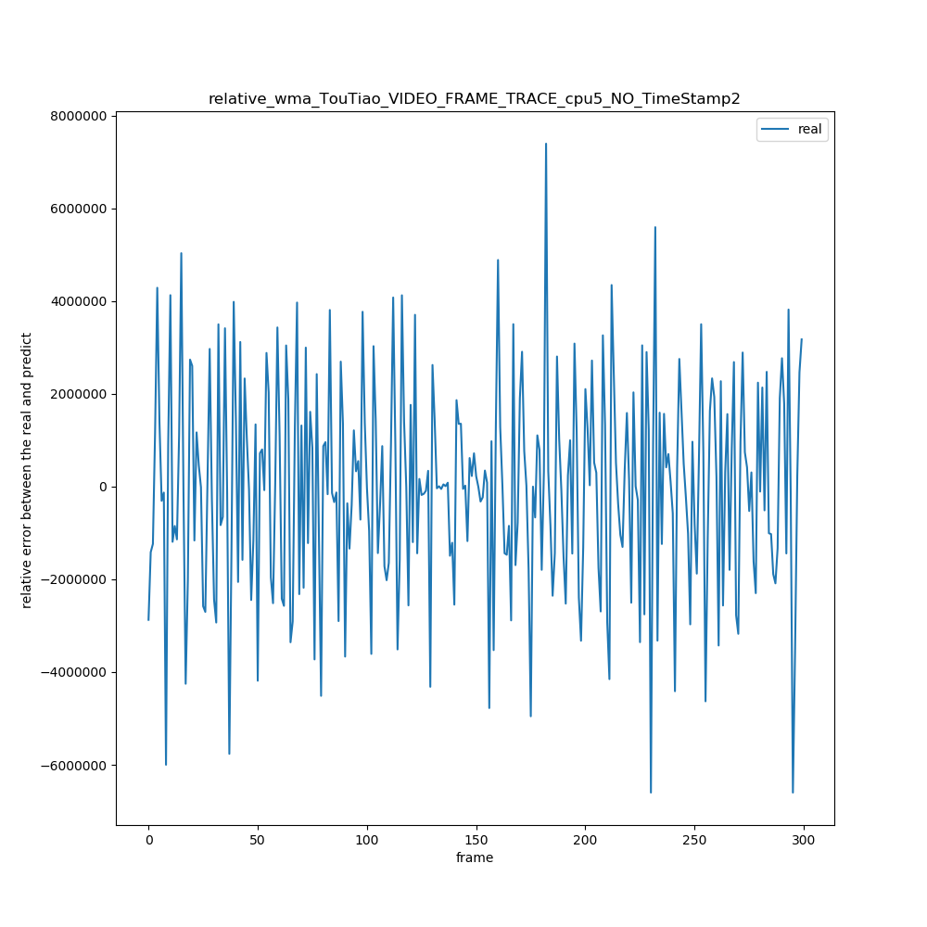

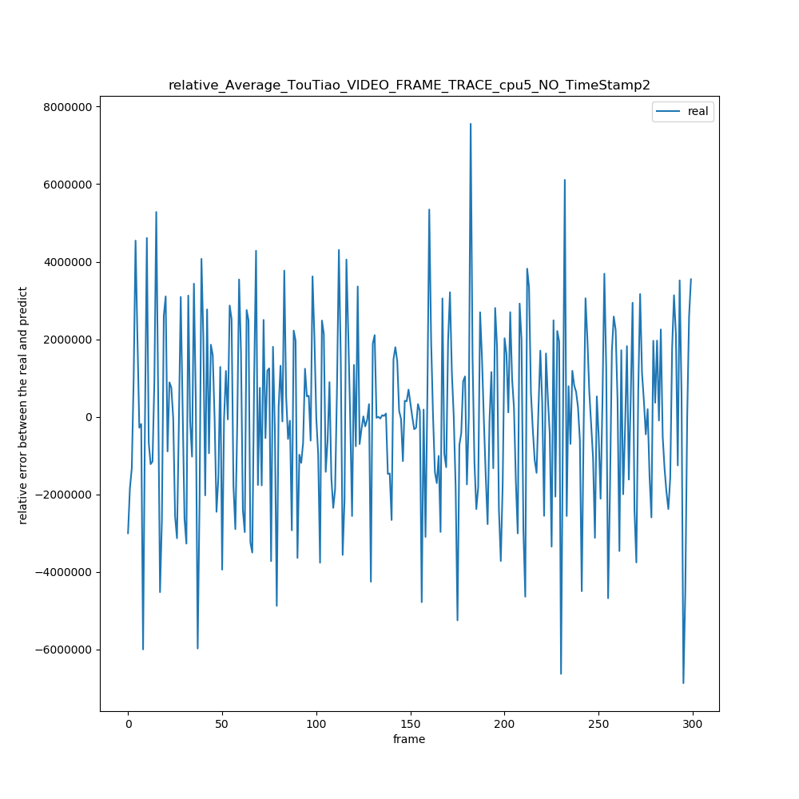

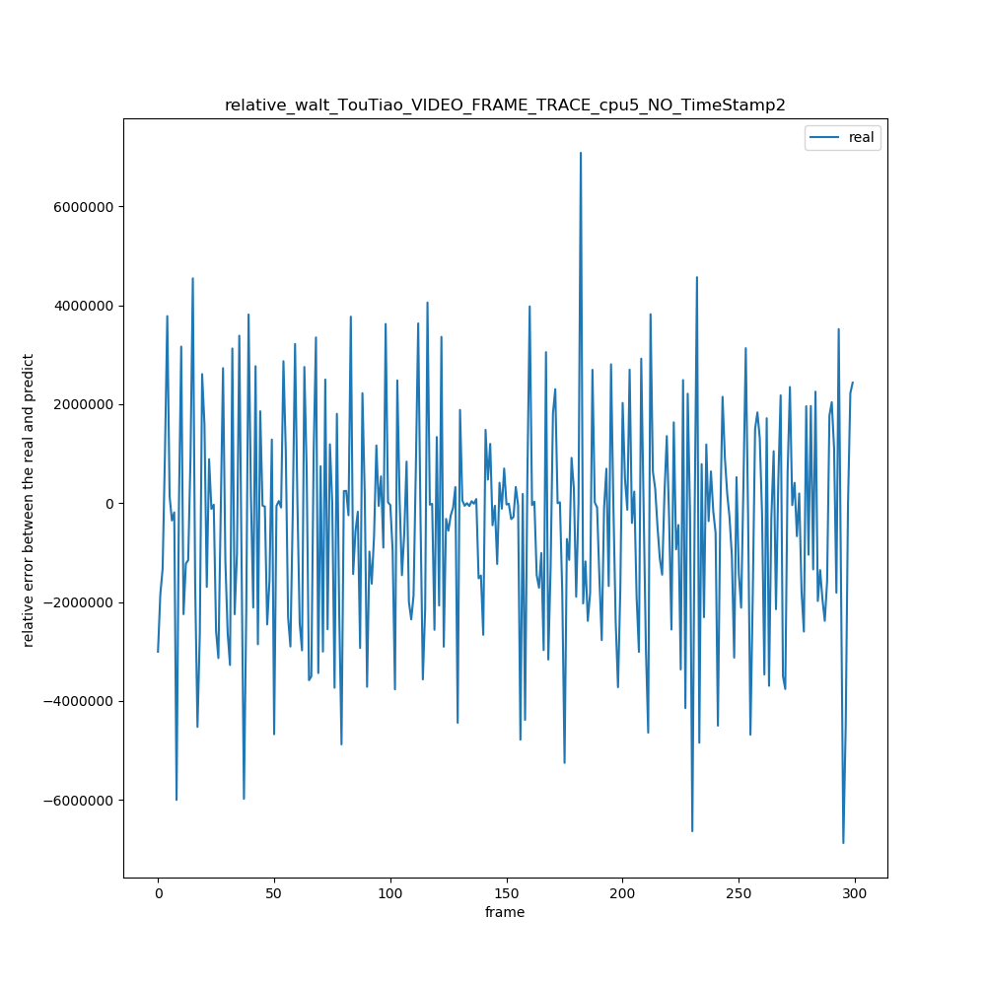

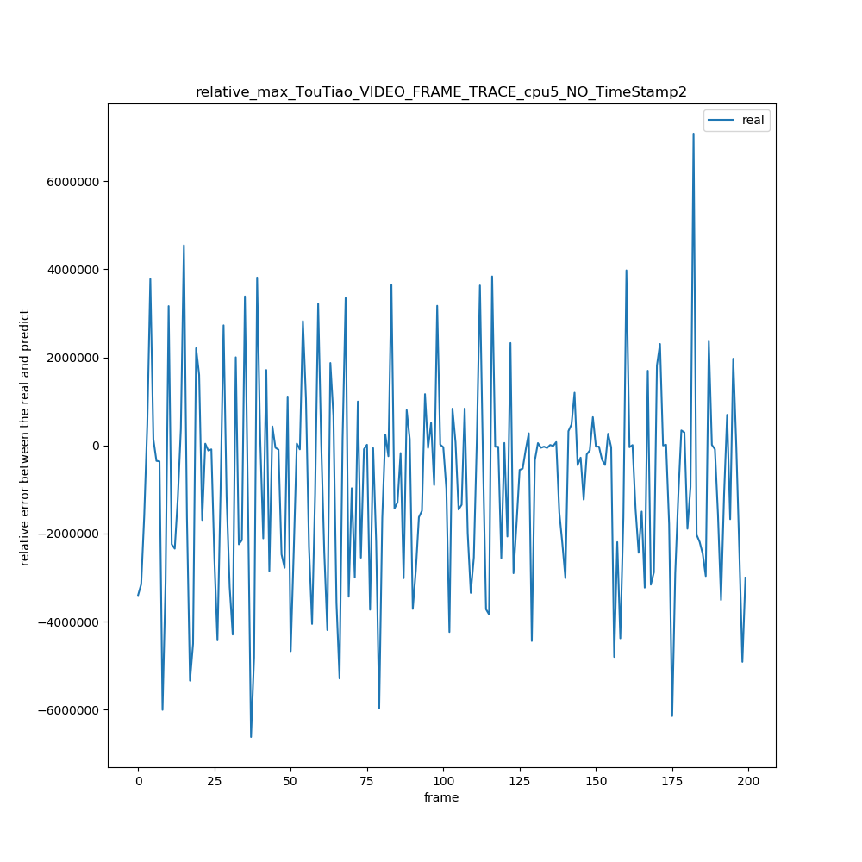

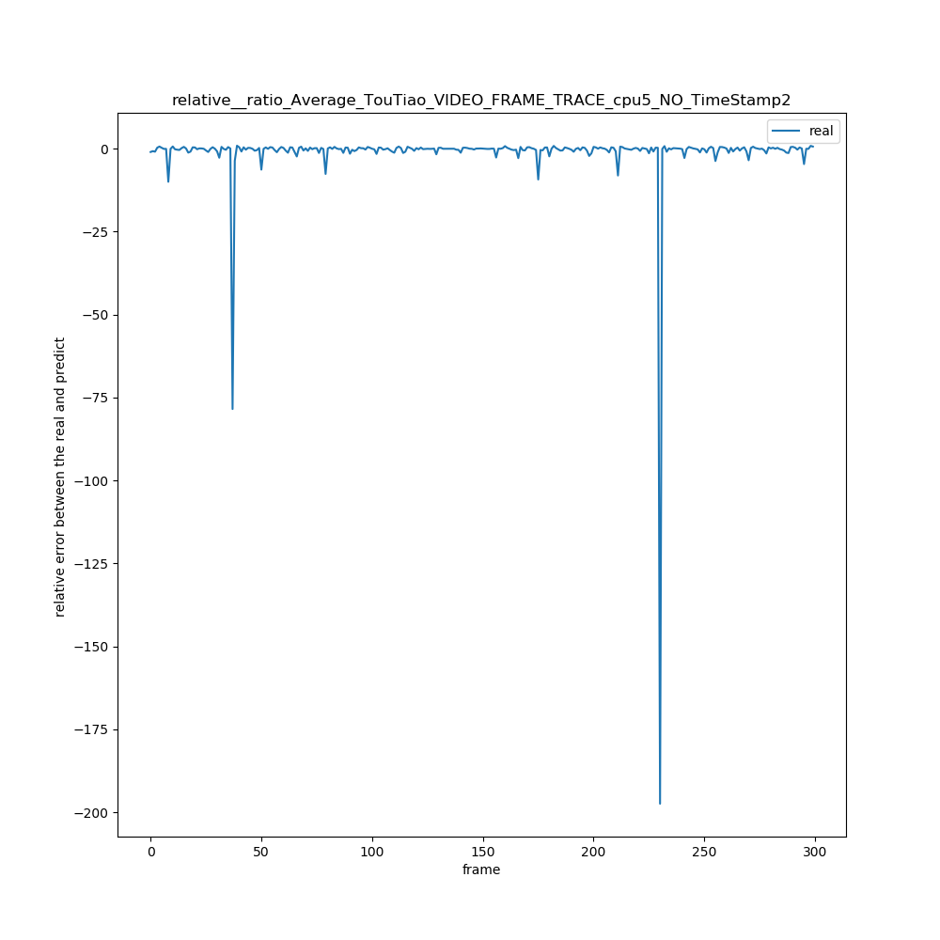

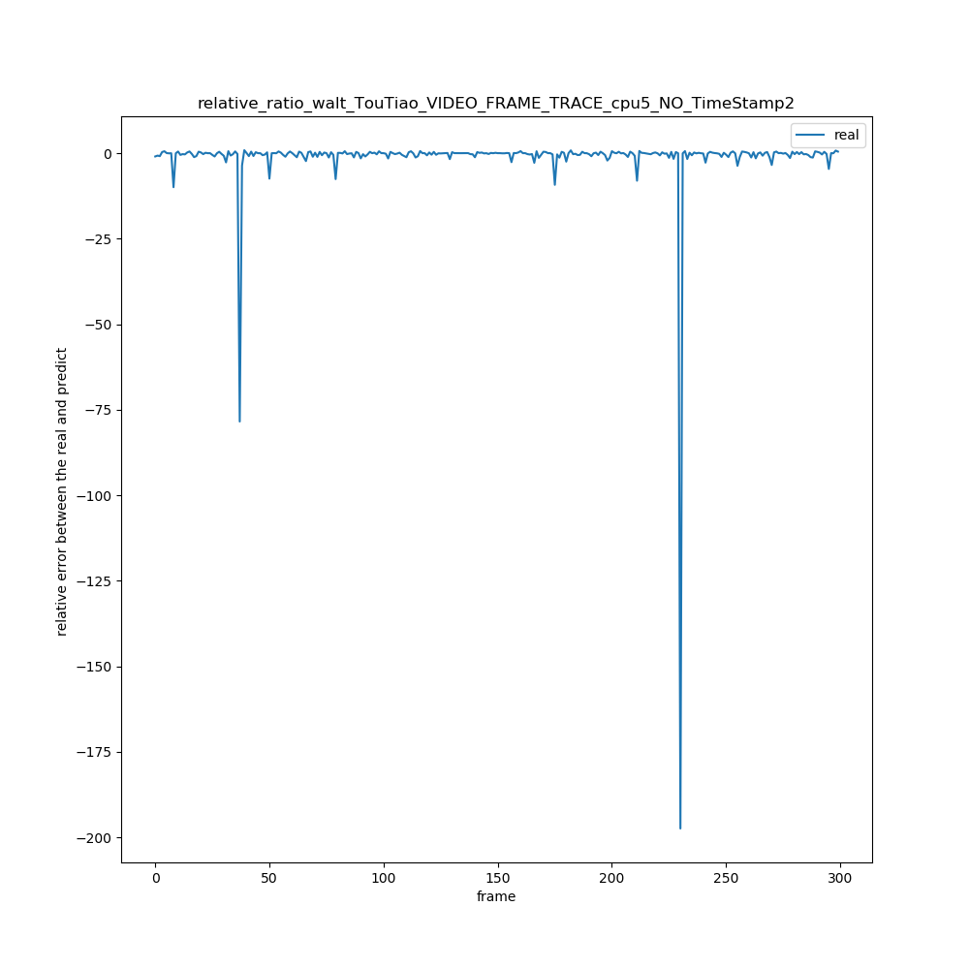

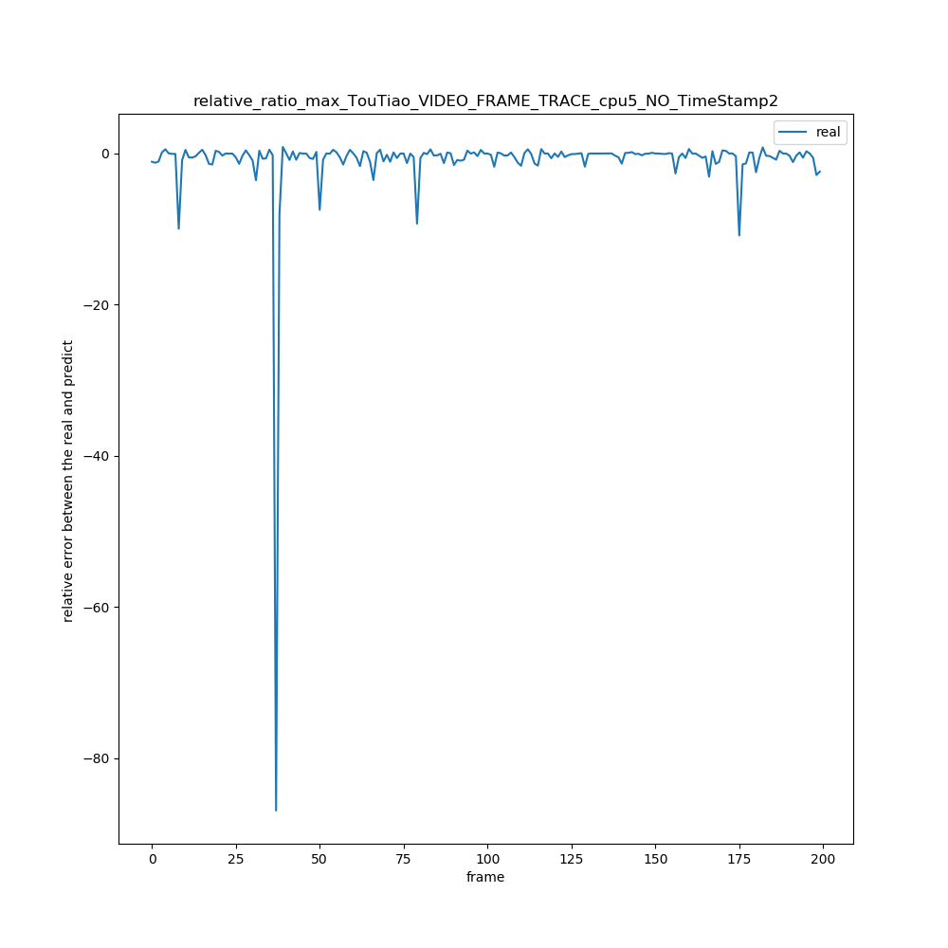

3 . UC_TRACE_NO_EVENTS_CYCLE/UC_SLIDE_FRAME_TRACE3_cpu4_NO_TimeStamp"

|  |  |  |  |  |  |  |  |  |  |
| --- | --- | --- | --- | --- | --- | --- | --- | --- | --- |
| 绝对误差值平均x = ∑abs(real[i] – predict[i]) / (real数组的长度) | N = 1 | N = 2 | N =3 | N =4 | N =5 | N =6 | N = 7 | N = 8 | N = 9 |
| WMA | 699149 | 726201 | 739487 | 735517 | 737390 | 747198 | 755709 | 758116 | 760238 |
| AVERAGE | 699149 | 763652 | 781049 | 748364 | 758241 | 786297 | 787246 | 789121 | 789979 |
| WALT | 699149 | 759130 | 778730 | 759143 | 766993 | 784429 | 793477 | 787342 | 788667 |
| MAX | 699149 | 877096 | 995114 | 1069548 | 1166348 | 1258434 | 1348603 | 1421659 | 1491900 |

|  |  |  |  |  |  |  |  |  |  |
| --- | --- | --- | --- | --- | --- | --- | --- | --- | --- |
| 相对误差率平均x =(∑（predict[i] – real[i]）/ real[i])/ (real数组长度) | N = 1 | N = 2 | N =3 | N =4 | N =5 | N =6 | N = 7 | N = 8 | N = 9 |
| WMA | 0.9 | 1.15 | 1.21 | 1.2 | 1.2 | 1.22 | 1.25 | 1.27 | 1.29 |
| AVERAGE | 0.9 | 1.26 | 1.26 | 1.19 | 1.20 | 1.28 | 1.34 | 1.35 | 1.38 |
| WALT | 0.9 | 1.53 | 1.66 | 1.68 | 1.70 | 1.78 | 1.87 | 1.91 | 1.94 |
| MAX | 0.9 | 2.12 | 2.72 | 3.17 | 3.51 | 3.89 | 4.3 | 4.6 | 4.9 |

|  |  |  |  |  |  |  |  |  |  |
| --- | --- | --- | --- | --- | --- | --- | --- | --- | --- |
| 相对误差率绝对平均x =(∑（（abs(predict[i] – real[i])）/ real[i])/ (real数组长度) | N = 1 | N = 2 | N =3 | N =4 | N =5 | N =6 | N = 7 | N = 8 | N = 9 |
| WMA | 1.7 | 1.84 | 1.84 | 1.81 | 1.79 | 1.80 | 1.82 | 1.83 | 1.85 |
| AVERAGE | 1.7 | 1.95 | 1.91 | 1.78 | 1.78 | 1.86 | 1.92 | 1.90 | 1.92 |
| WALT | 1.7 | 2.10 | 2.15 | 2.11 | 2.12 | 2.19 | 2.26 | 2.28 | 2.30 |
| MAX | 1.7 | 2.6 | 3.0 | 3.4 | 3.7 | 4.0 | 4.4 | 4.7 | 5.0 |

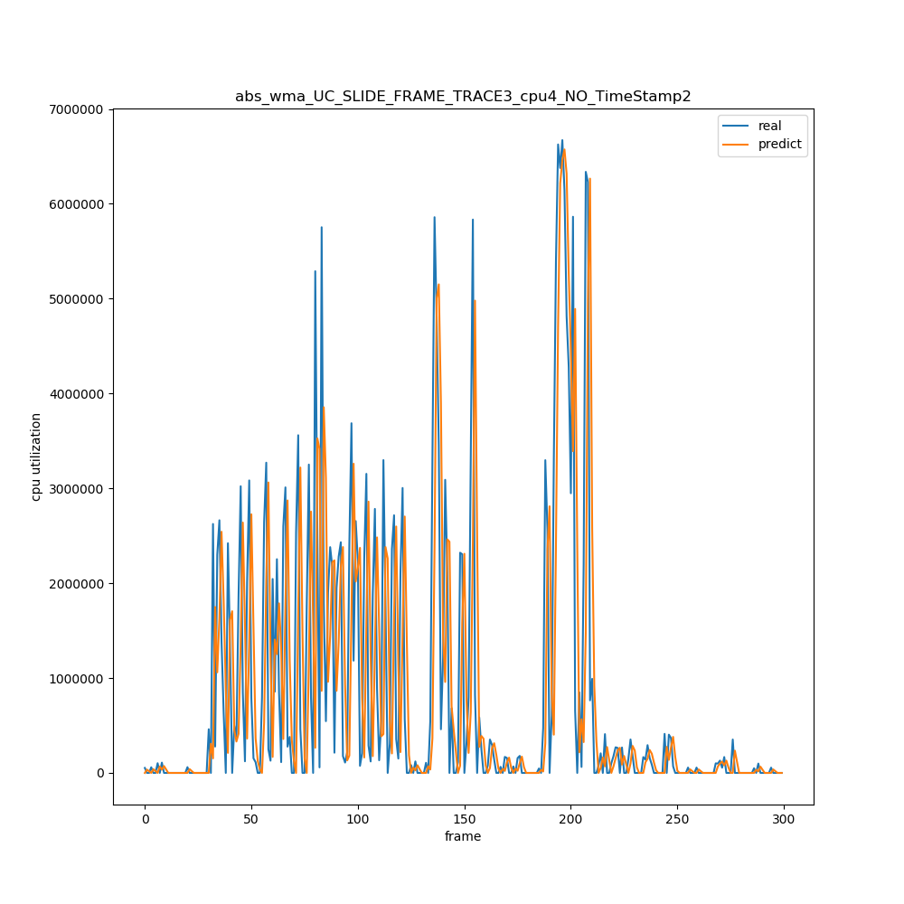

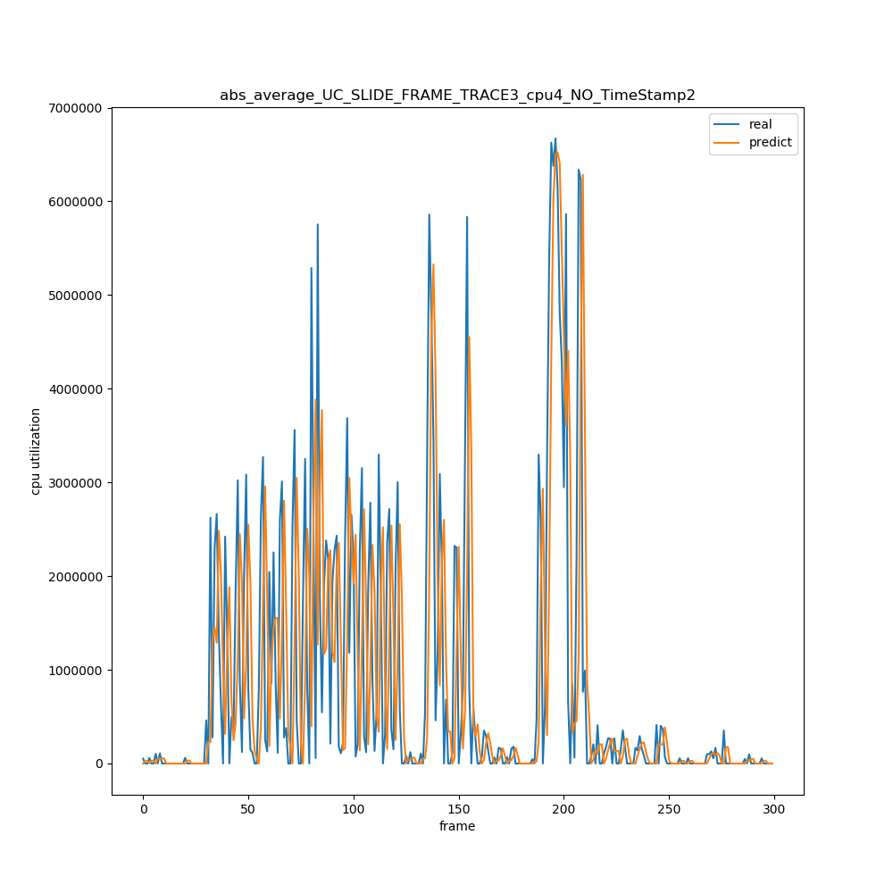

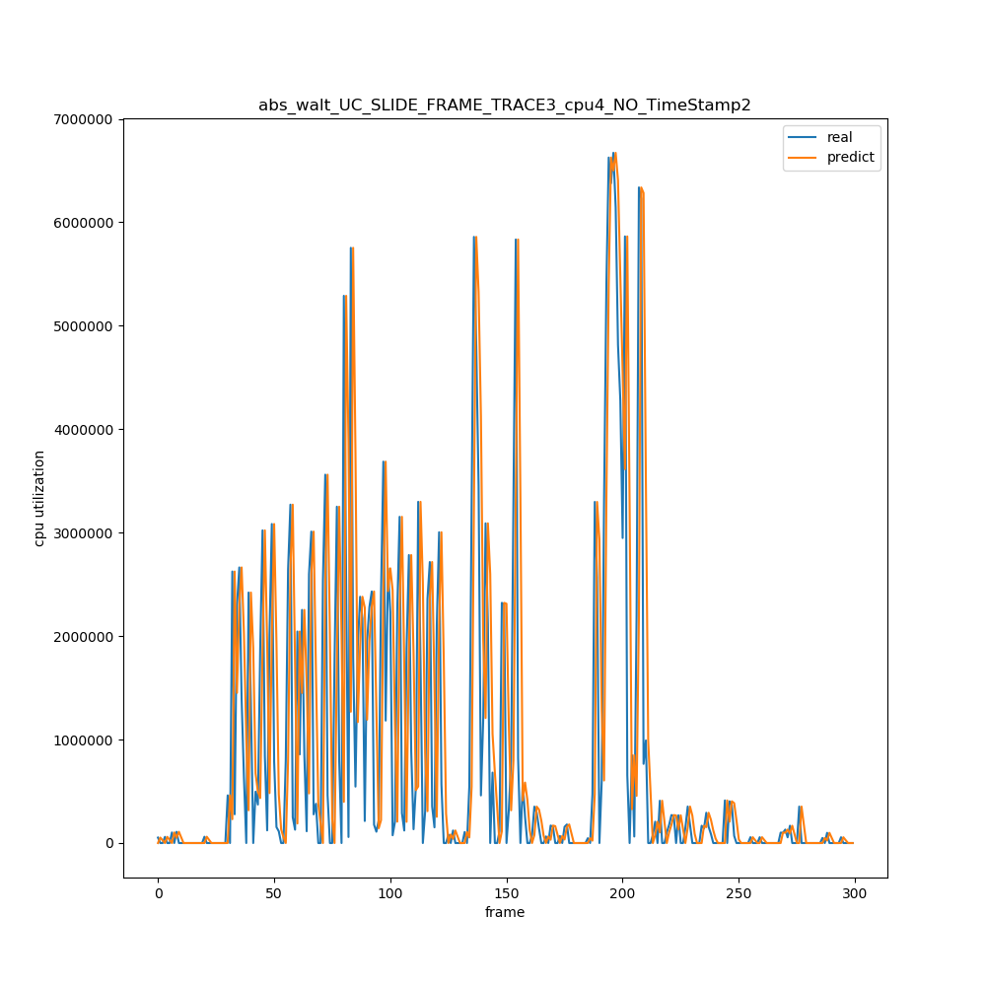

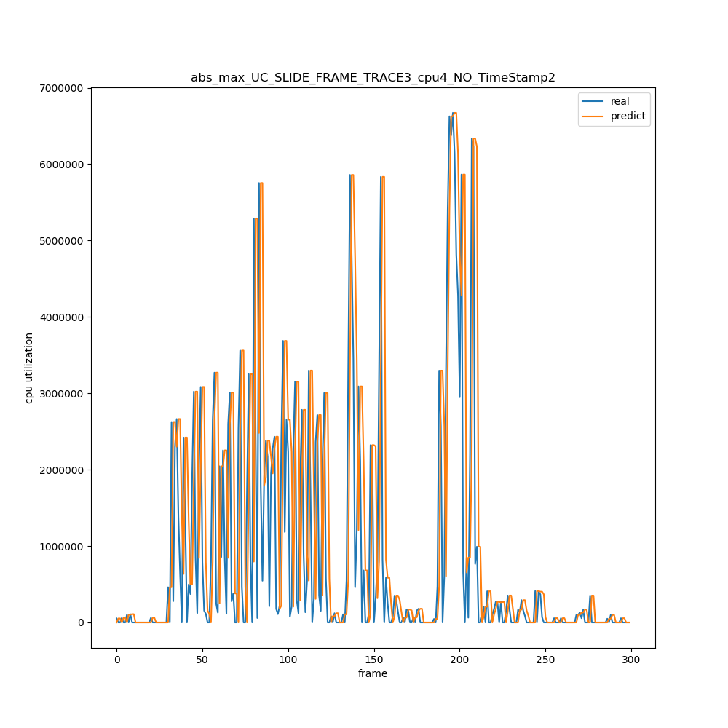

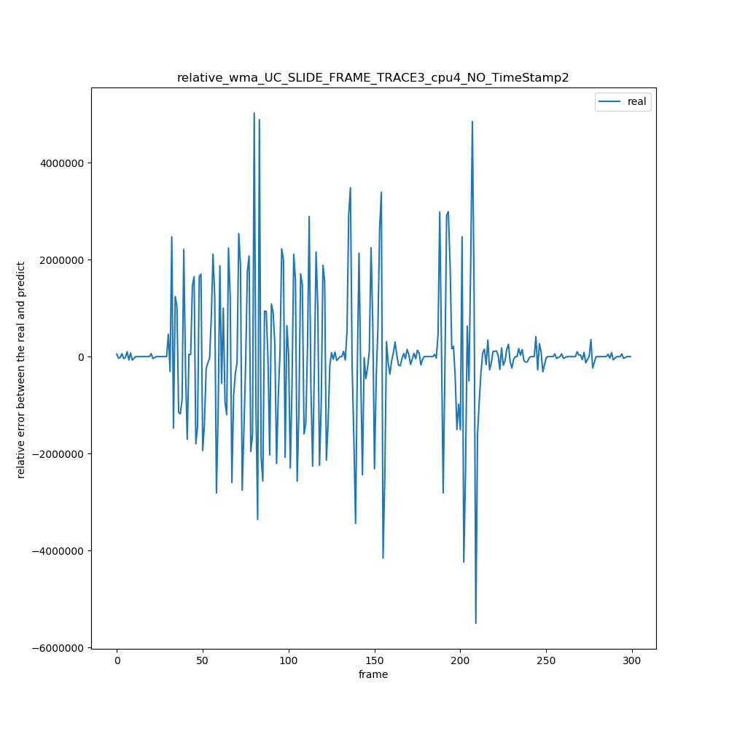

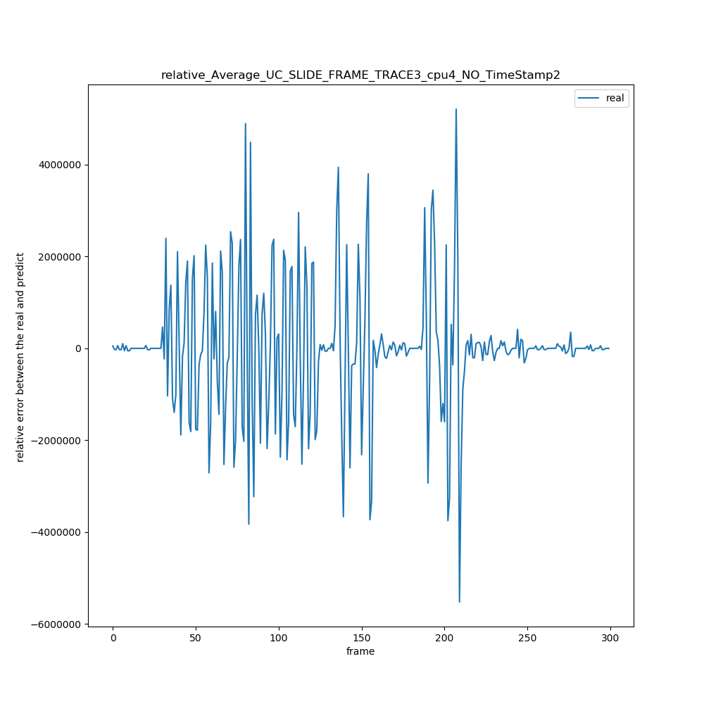

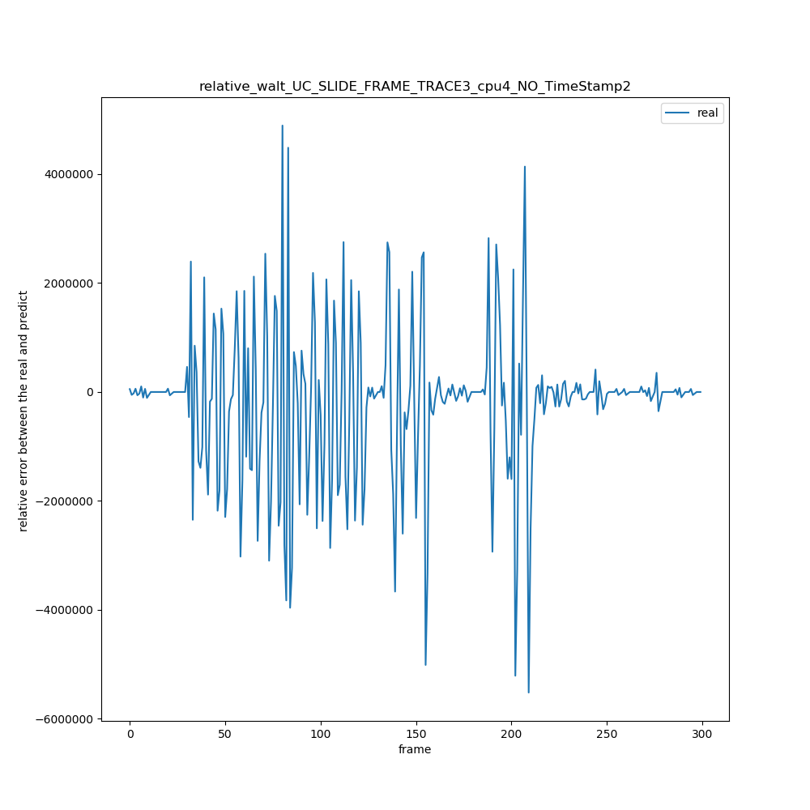

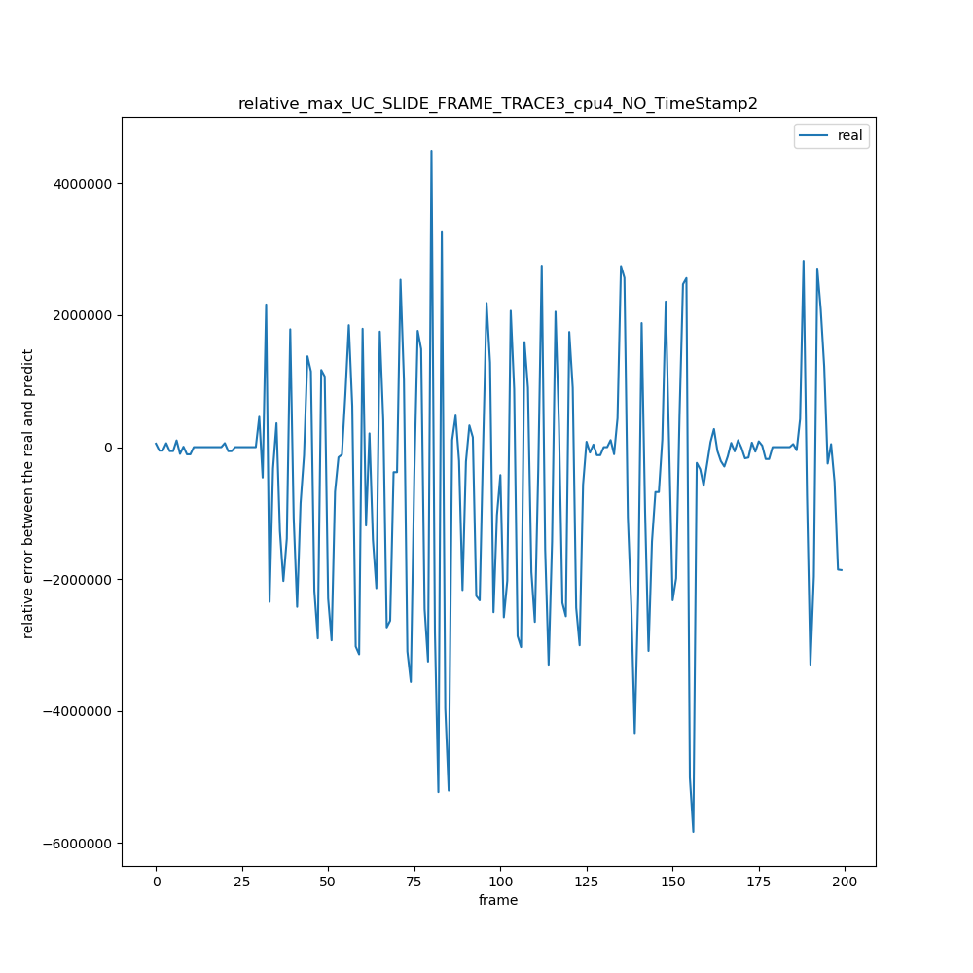

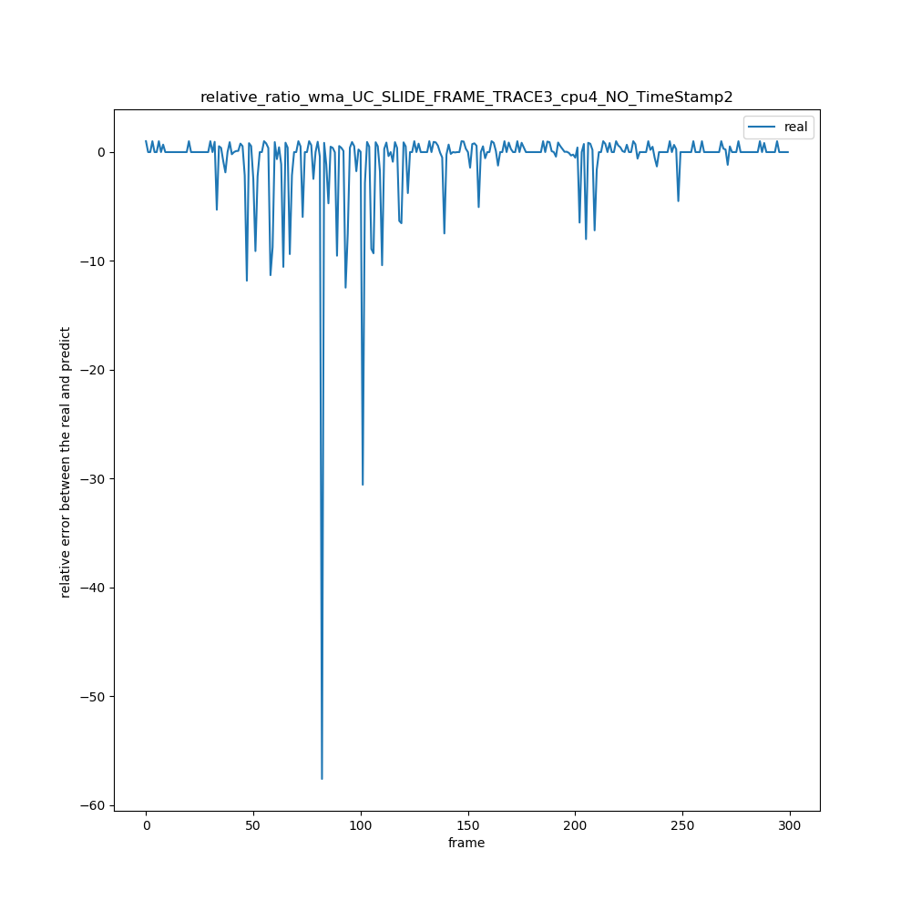

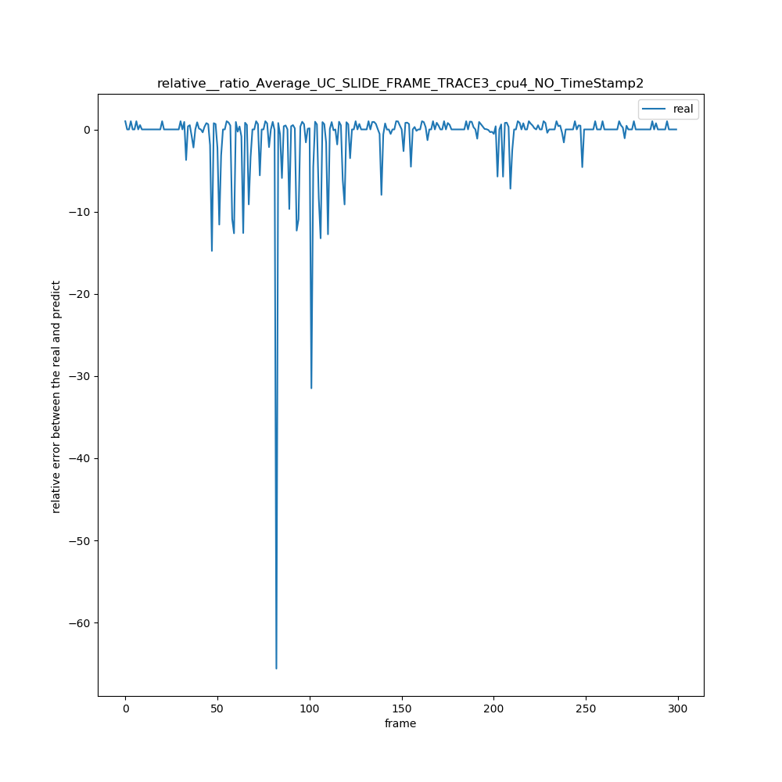

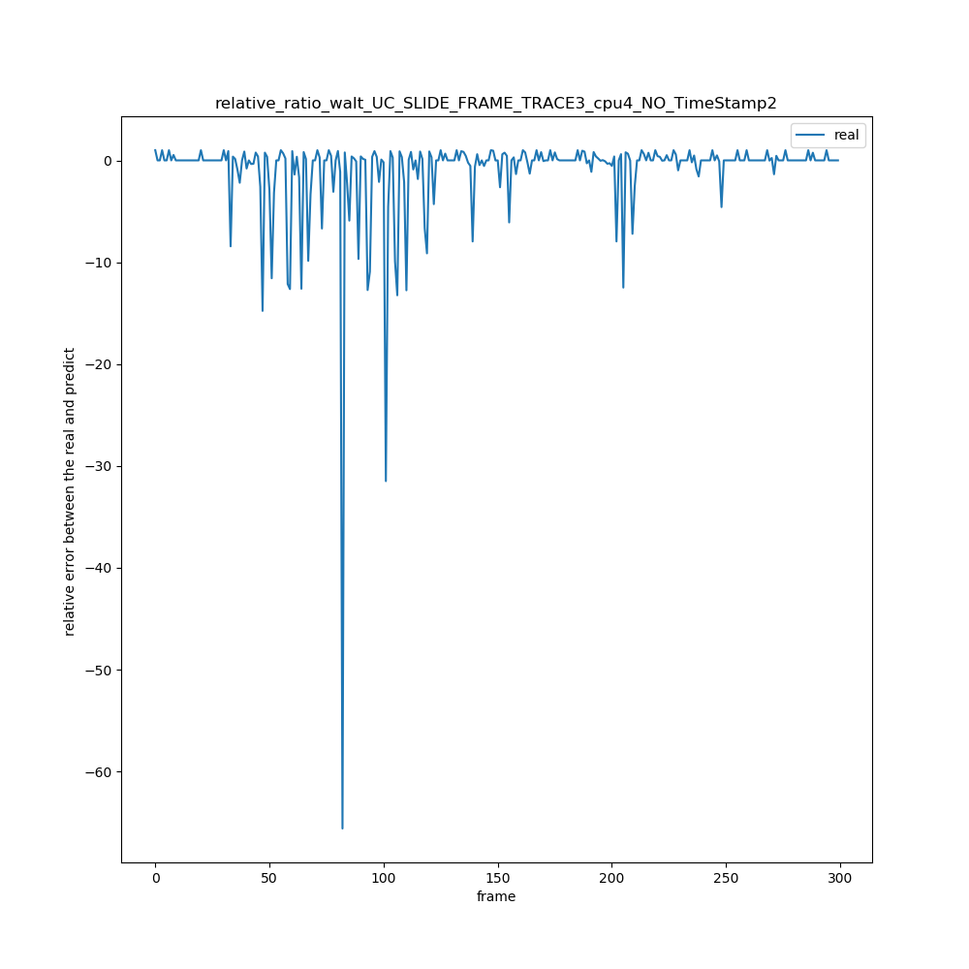

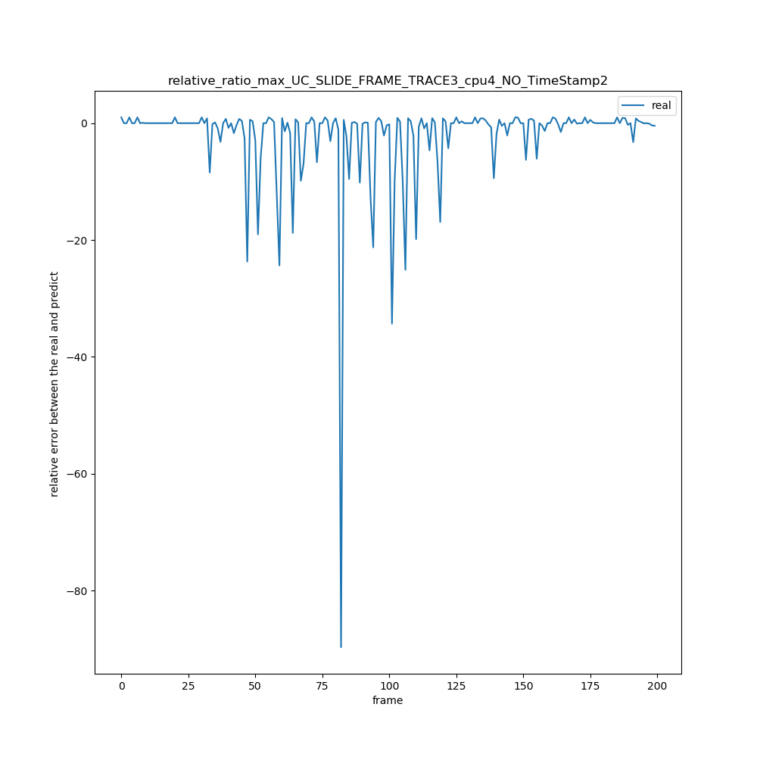

4

WeiBo_TRACE_NO_EVENTS_UTIL\WeiBo_Pic_SLIDE_FRAME_TRACE_NO_TimeStamp

|  |  |  |  |  |  |  |  |  |  |
| --- | --- | --- | --- | --- | --- | --- | --- | --- | --- |
| 绝对误差值平均x = ∑abs(real[i] – predict[i]) / (real数组的长度) | N = 1 | N = 2 | N =3 | N =4 | N =5 | N =6 | N = 7 | N = 8 | N = 9 |
| WMA | 536745 | 546130 | 542027 | 534385 | 537778 | 550644 | 562975 | 570689 | 578278 |
| AVERAGE | 536745 | 567954 | 557695 | 537201 | 559225 | 597573 | 613771 | 611461 | 6191119 |
| WALT | 536745 | 566484 | 561637 | 558405 | 568520 | 592859 | 602471 | 604833 | 609035 |
| MAX | 536745 | 643455 | 735525 | 798228 | 879723 | 964774 | 1045001 | 1116986 | 1187265 |

|  |  |  |  |  |  |  |  |  |  |
| --- | --- | --- | --- | --- | --- | --- | --- | --- | --- |
| 相对误差率平均x =(∑（predict[i] – real[i]）/ real[i])/ (real数组长度) | N = 1 | N = 2 | N =3 | N =4 | N =5 | N =6 | N = 7 | N = 8 | N = 9 |
| WMA | 0.88 | 1.0 | 1.09 | 1.09 | 1.11 | 1.18 | 1.24 | 1.29 | 1.33 |
| AVERAGE | 0.88 | 1.10 | 1.15 | 1.09 | 1.16 | 1.34 | 1.44 | 1.46 | 1.5 |
| WALT | 0.88 | 1.42 | 1.59 | 1.61 | 1.66 | 1.82 | 1.94 | 2.00 | 2.03 |
| MAX | 0.88 | 1.96 | 2.57 | 2.99 | 3.37 | 4.11 | 4.52 | 4.82 | 5.03 |

|  |  |  |  |  |  |  |  |  |  |
| --- | --- | --- | --- | --- | --- | --- | --- | --- | --- |
| 相对误差率绝对平均x =(∑（（abs(predict[i] – real[i])）/ real[i])/ (real数组长度) | N = 1 | N = 2 | N =3 | N =4 | N =5 | N =6 | N = 7 | N = 8 | N = 9 |
| WMA | 1.65 | 1.7 | 1.69 | 1.65 | 1.65 | 1.70 | 1.76 | 1.80 | 1.84 |
| AVERAGE | 1.65 | 1.77 | 1.73 | 1.61 | 1.68 | 1.87 | 1.96 | 1.96 | 1.99 |
| WALT | 1.65 | 1.77 | 1.73 | 1.61 | 1.68 | 1.87 | 1.96 | 1.96 | 1.99 |
| MAX | 1.65 | 2.43 | 2.87 | 3.2 | 3.5 | 4.2 | 4.6 | 4.9 | 5.1 |

